04 · Roles and Responsibilities
Project: StaffSync — HRM System Document type: Story
Status: In Progress · Owner: Shiwani Jha

1. Roles at a Glance
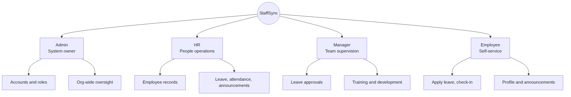
Role | Value in code | How the account is created
Employee | employee | Public registration (default) or added by HR/Admin
Manager | manager | Registration with ROLE_SETUP_CODE, or added by HR/Admin
HR | hr | Registration with ROLE_SETUP_CODE, or added by Admin
Admin | admin | npm run create-admin CLI, or ROLE_SETUP_CODE

2. Responsibilities

2.1 Manage Employee Records Efficiently
HR personnel (and Admin) create, view, update and deactivate employee records to keep employee information and organizational data accurate. Records are soft-deleted (isActive = false) to preserve history.

2.2 Handle Leave Management Processes
Employees apply for leave. Managers and HR personnel review, approve or reject applications, adding a review note, to keep workforce planning smooth.

2.3 Track and Monitor Attendance
Employees mark attendance regularly through check-in and check-out. HR personnel monitor attendance records, correct entries manually, and maintain accurate data for payroll and performance evaluation.

2.4 Manage Training and Development Programs
Managers (and HR/Admin) create, schedule and monitor training programs to support employee skill development and professional growth.

2.5 Post and Review Announcements
HR personnel (and Admin) create and publish company announcements, notifications and updates, targeted by audience, to ensure effective communication across the organization.

2.6 Maintain Personal Employee Information
Employees update and manage their own profile (name, phone, department) to keep information accurate and up to date.

2.7 Ensure Secure Access and Authentication
All users keep their login credentials confidential and access only the features permitted for their assigned role.

2.8 Review Organizational Updates
Employees regularly check announcements, leave status updates, attendance records and training notices to stay informed about company activities.

2.9 Generate and Monitor Reports
HR personnel review attendance, leave records and employee information to support administrative decision-making and workforce management.

2.10 Support Role-Based Operations
The system provides dedicated dashboards for HR, Managers and Employees. Users utilize the features available within their designated roles.

3. Responsibility by Role
Responsibility | Employee | Manager | HR | Admin
Update own profile | ✔ | ✔ | ✔ | ✔
Check-in / check-out | ✔ | ✔ | ✔ | ✔
Apply for leave | ✔ | ✔ | ✔ | ✔
Review announcements | ✔ | ✔ | ✔ | ✔
Approve / reject leave |  | ✔ | ✔ | ✔
View employee directory |  | ✔ | ✔ | ✔
Monitor team attendance |  | ✔ | ✔
Manage training programs |  | ✔ | ✔ | ✔
Post announcements |  |  | ✔ | ✔
Add / edit / deactivate employees |  |  | ✔ | ✔
Manual attendance correction |  |  | ✔ | ✔
Assign roles |  |  | ✔ | ✔

4. Permission Matrix (as enforced by the API)
Endpoint | Employee | Manager | HR | Admin
GET /api/employees | ✖ | ✔ | ✔ | ✔
POST /api/employees | ✖ | ✖ | ✔ | ✔
PATCH /api/employees/:id | ✖ | ✖ | ✔ | ✔
DELETE /api/employees/:id | ✖ | ✖ | ✔ | ✔
GET /api/attendance (own) | ✔ | ✔ | ✔ | ✔
GET /api/attendance?all=true | ✖ | ✔ | ✔ | see note A
POST /api/attendance/check-in / check-out | ✔ | ✔ | ✔ | ✔
POST /api/attendance/manual | ✖ | ✖ | ✔ | ✔
GET /api/leaves (own) | ✔ | ✔ | ✔ | ✔
GET /api/leaves?all=true | ✖ | ✔ | ✔ | see note A
POST /api/leaves | ✔ | ✔ | ✔ | ✔
PATCH /api/leaves/:id/review | ✖ | ✔ | ✔ | ✔
GET /api/announcements | ✔ | ✔ | ✔ | see note B
POST / DELETE /api/announcements | ✖ | ✖ | ✔ | ✔
GET /api/trainings | ✔ | ✔ | ✔ | ✔
POST / DELETE /api/trainings | ✖ | ✔ | ✔ | ✔
GET /api/dashboard | ✔ (personal) | ✔ (+ org stats) | ✔ (+ org stats) | ✔ (+ org stats)

5. Access-Control Decision Flow
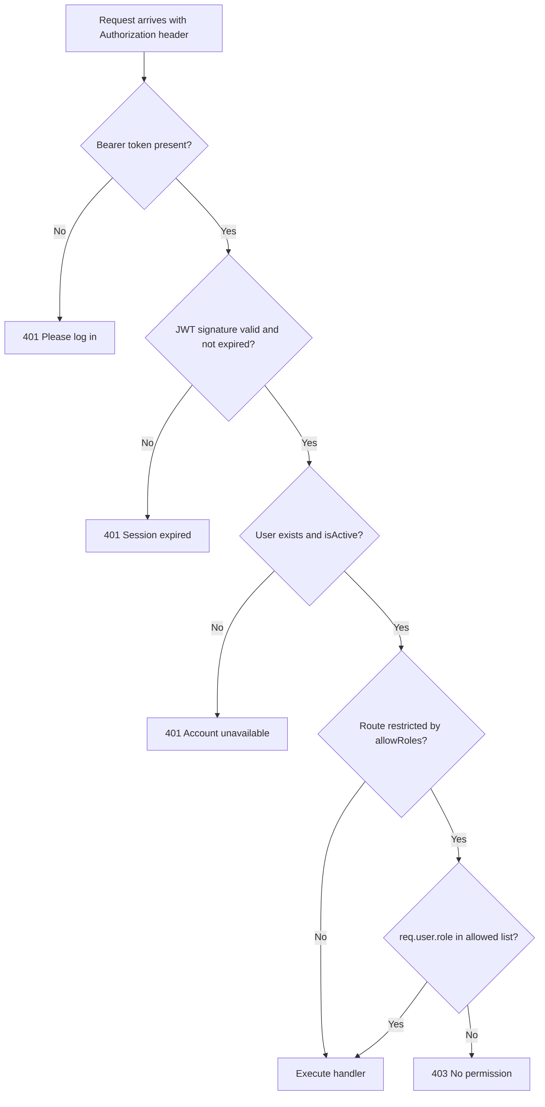

6. Account Provisioning Flow
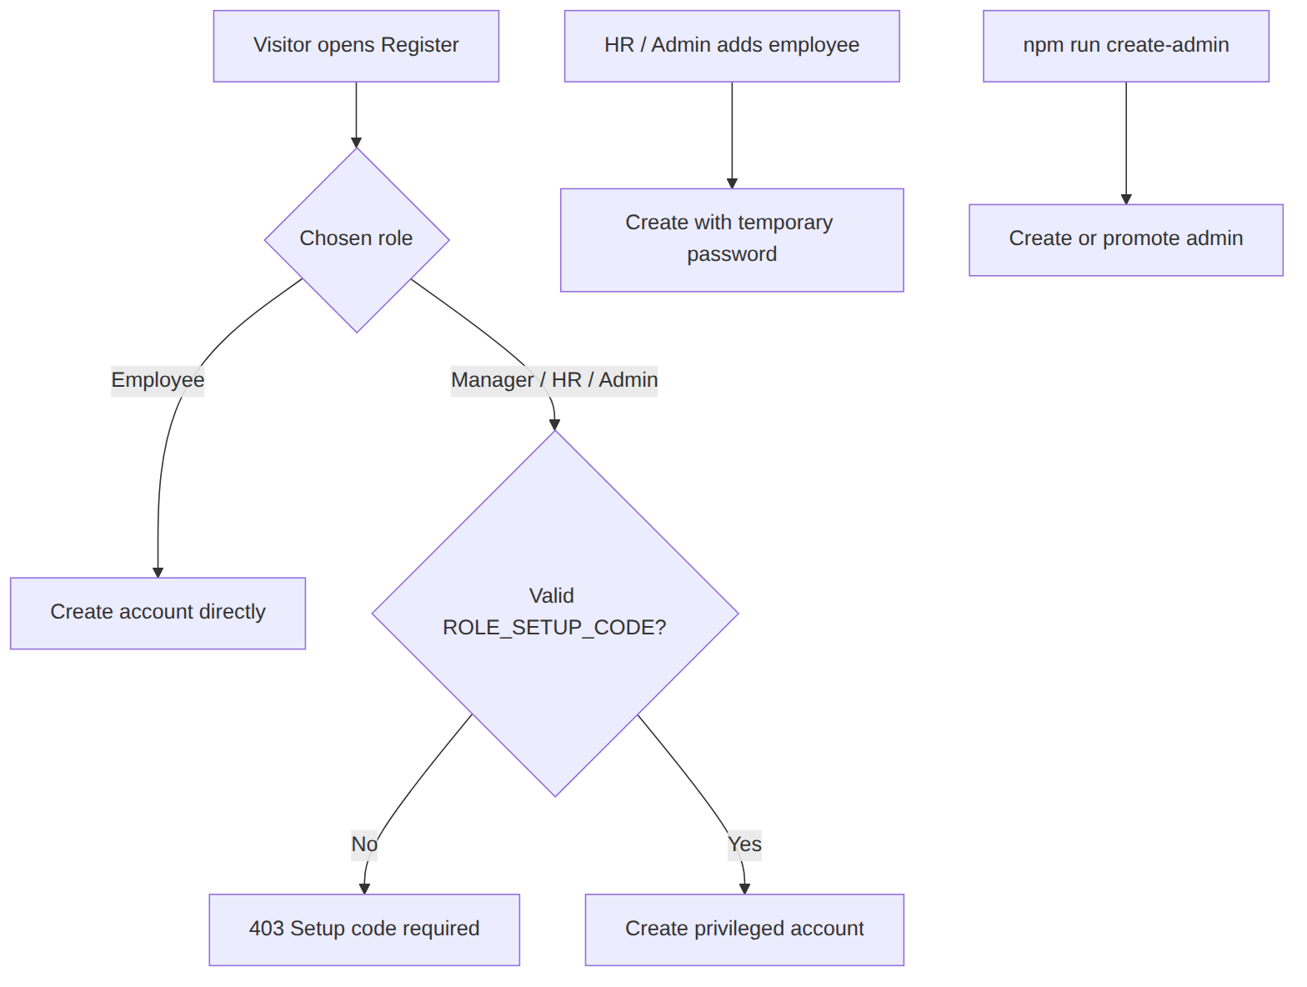

7. Implementation Notes
These are differences between the written specification and the current code. Worth a look before the final demo or review.
- Note A: ?all=true on attendance and leave listings is honored for hr and manager only. Admin currently sees only their own records there. Adding 'admin' to the role check fixes this.
- Note B: the announcement audience filter has no branch for admin, so admins fall into the Employees audience (Everyone + Employees).
- Manager announcements: the specification says HR and managers can post announcements. The API currently allows admin and hr only.
- Designation: the designation field was removed from the profile (single Role field). scripts/createAdmin.js still passes it, and Mongoose silently ignores it.

